

User manual

VR Medical Training Tool



April 17, 2023

Jeremy Cavallo, SLav Ivaskiv, Robert Tedeschi, Luka Cvetko

Table of Contents

Introduction 1

Before You Start 1

Supported Platforms 1

System Requirements 1

Installation 1

Side Loading With SideQuest 1

Controls 8

Interface 9

Main Menu 9

Scenarios 10

Training Mode 12

Testing Mode 17

Testing Scores 23

Additional Notes 26

# Introduction

VR Medical Training Tool places you in a training environment that is designed to simulate first aid situations and teach you to act accordingly. While VR simulations have come forward a long way, this is by no means a direct replacement to real life training that you can receive. None the less, it should give user a good understanding of simulated scenarios and ensure their readiness unlike complete lack of training.

When play begins, you will be able to select provided scenarios that you would like to learn and test your knowledge upon successful completion of training.

# Before You Start

If you are familiar with general VR controls, you can jump right into action after installing the application. Otherwise, we strongly recommend familiarizing yourself with setup and controls in **the Controls** and **Interface** sections.

# Supported Platforms

This application was built with portability in mind in the first place. As such, target platforms are Oculus® Quest and Quest 2 with Rift being supported as well.

# System Requirements

Since Oculus Quest headsets are massively produced devices with same hardware specifications (per generation), there are no specific requirements for running application.

# Installation

Currently application can be installed through side loading with SideQuest. Second way of installing application will be directly from your device’s corresponding application store when it is published (Oculus Store). In the future, more installation methods might be available (document will be updated accordingly).

## Side Loading With SideQuest

1. Download APK from project repository Releases (<https://github.com/Vals9/vr-training-tool>).
2. Download and configure SideQuest. You can download it and find instructions for configuration at <https://sidequestvr.com/setup-howto>. You will need Advanced Installer in order to be able to install APKs.
3. Once you configure SideQuest and your device is detected, click on “Install APK file from folder on computer” .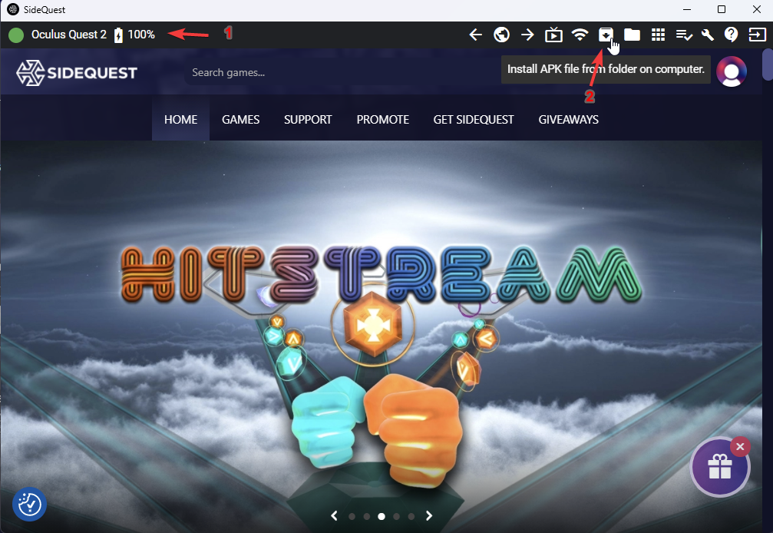

Figure 1 Application installation – Installing APK

1. Select downloaded APK. You can check installation progress under Task Manager 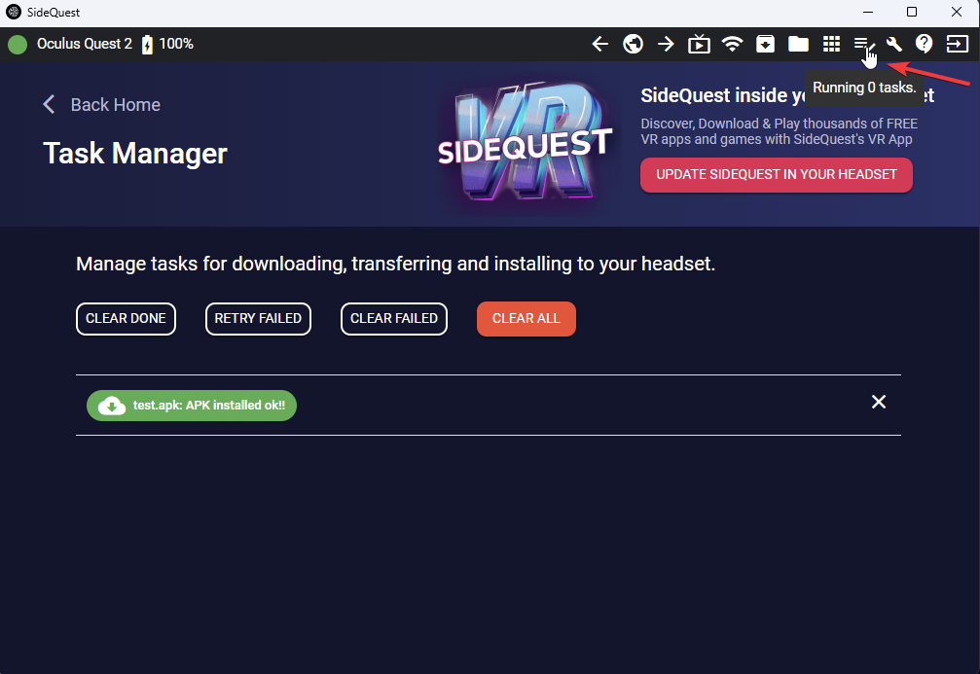

Figure 2 Application installation – Installing APK

1. Next, select App Library in your headset (example shown with Quest 2)

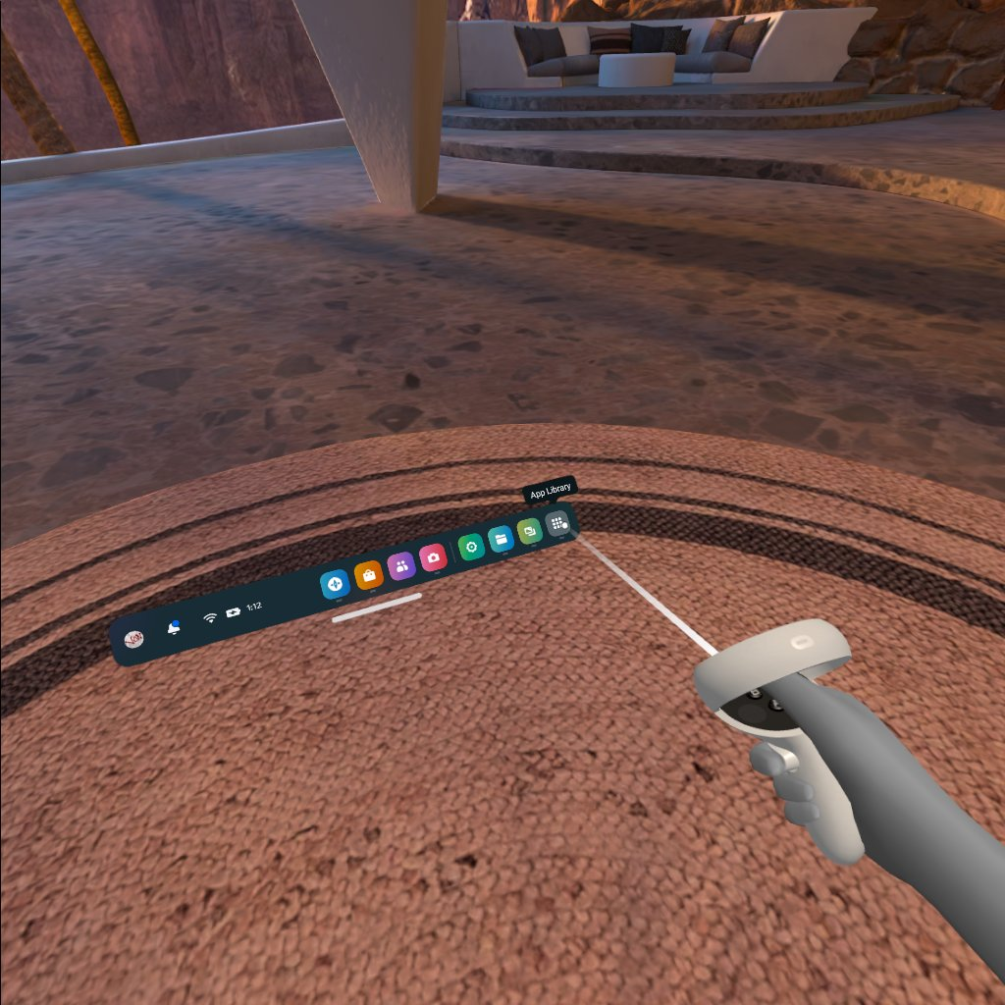

Figure 3 Application installation – Finding Installed Application

1. Click on filter icon in the upper right corner

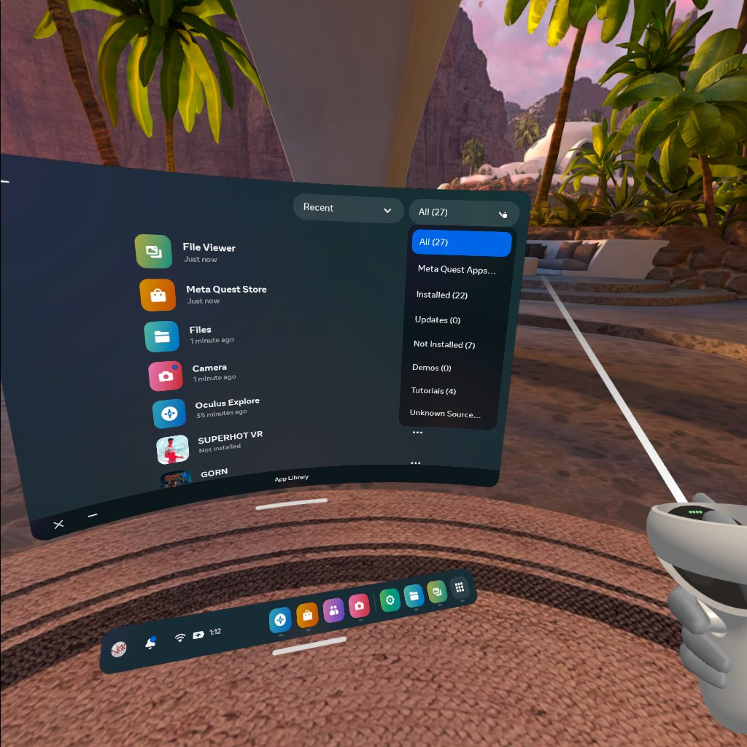

Figure 4 Application installation – Finding Installed Application

1. Click on Unknown Sources

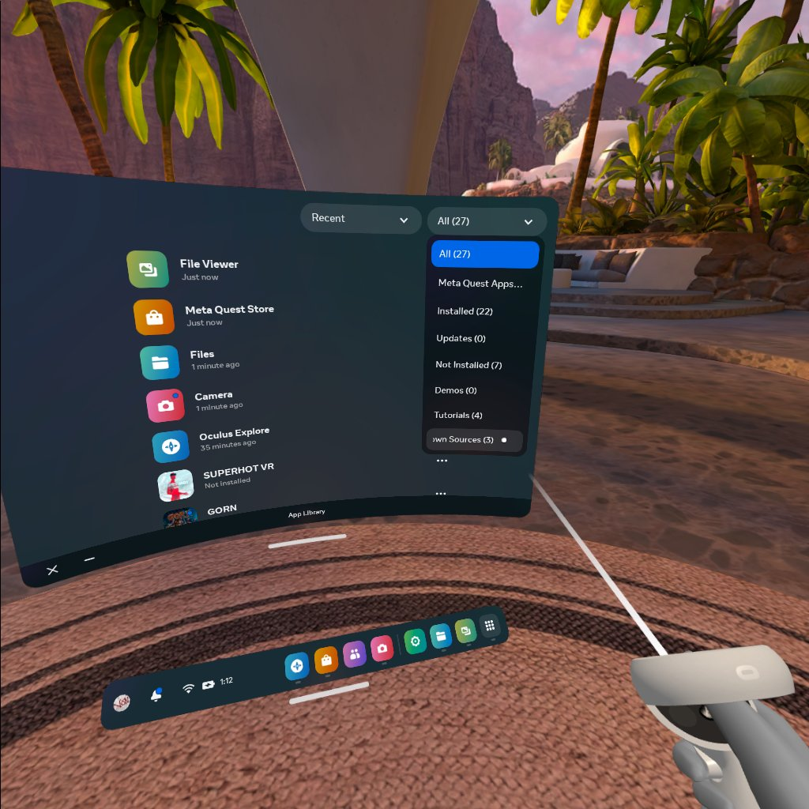

Figure 5 Application installation – Finding Installed Application

1. You should see vr-training-tool application

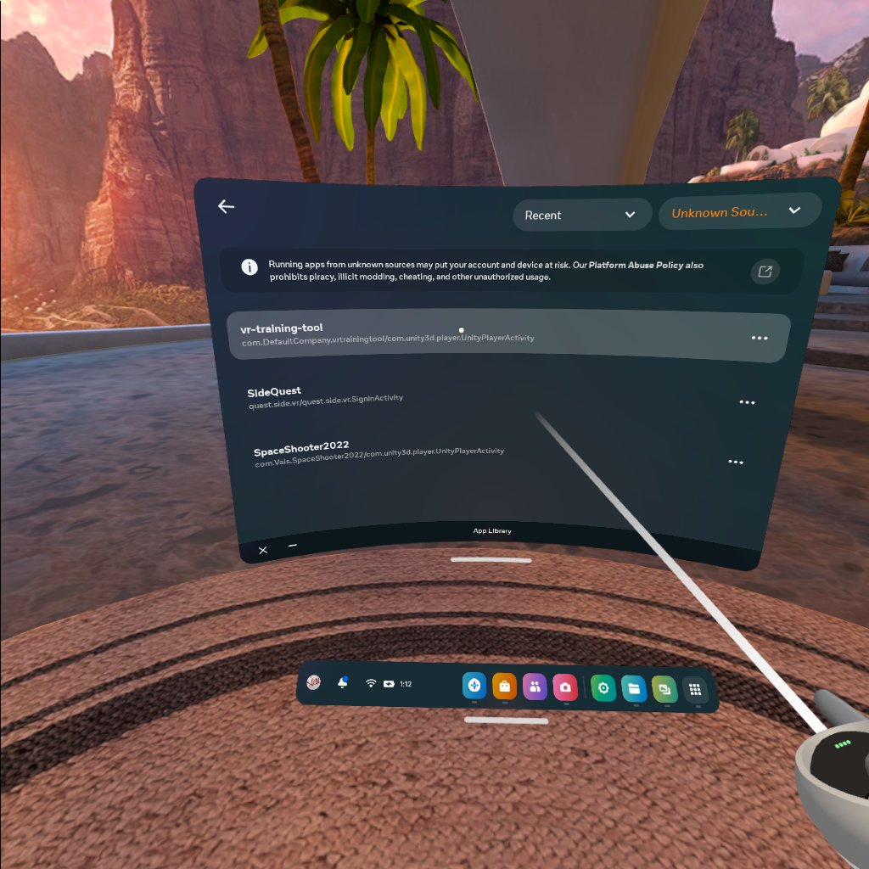

Figure 6 Application installation – Finding Installed Application

# Controls

Application implements common control scheme, utilizing Triggers (6) and Grip buttons (5) for interactions. For simplicity and/or usage in limited space, left Thumbstick (1) is used for movement and right Thumbstick (1) is used for Camera rotation. Please note that you do not have to use thumbsticks and can freely navigate through environments with physical movement. Ray Interactors are used for UI interaction. Ray Interactors are replaced with hand model for scenario interactions.

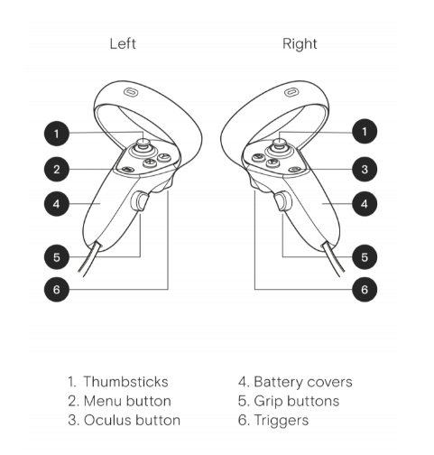

Figure 7 Controller Buttons Mapping

# Interface

## Main Menu

Main Menu provides a selection of currently available scenarios. All provided scenarios can be selected and completed in any order. User can also reset their progress if they wish to finish complete training mode again or allow other users to complete it.

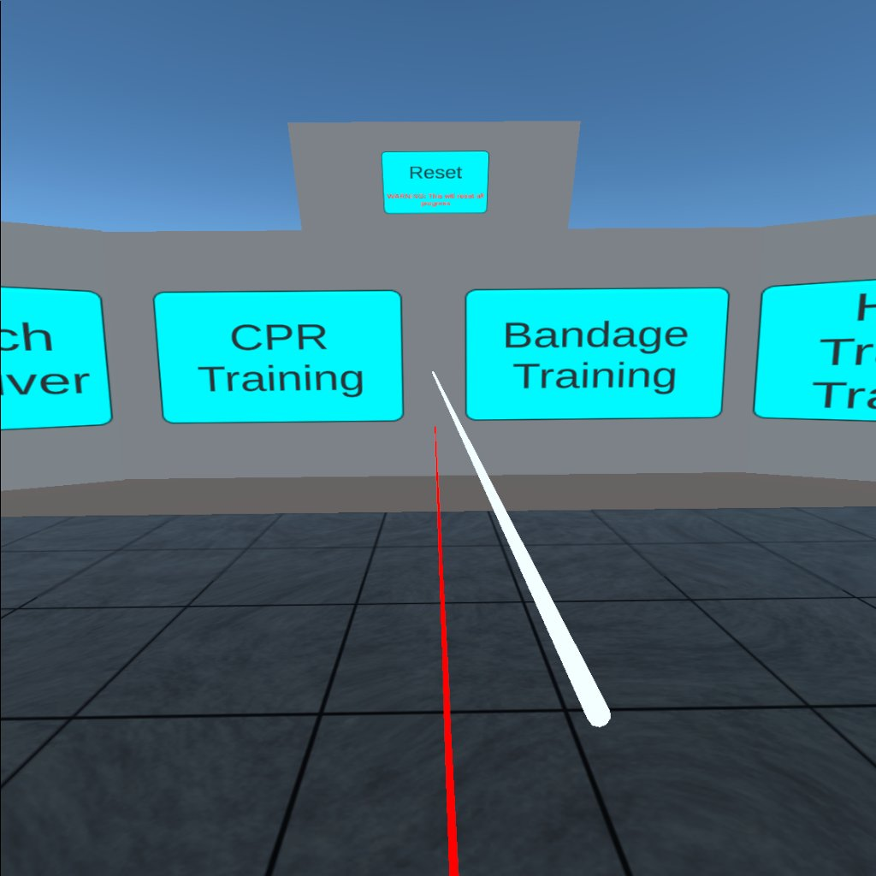

Figure 8 Main Menu - Reset Progress

## Scenarios

Each scene begins with interface to select sub scenario and/or mode (some scenarios have more than 1 sub scenario).

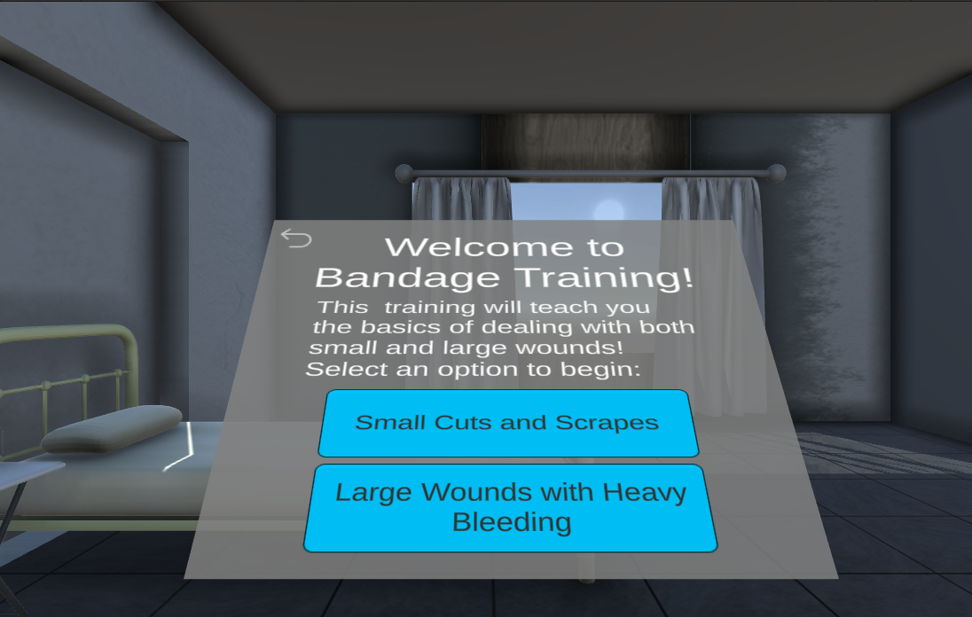

Figure 9 Bandage Scene - Sub Scenario Selection

Testing mode is initially locked. Users are required to complete Training mode first to familiarize themselves with steps they are tasked to complete.

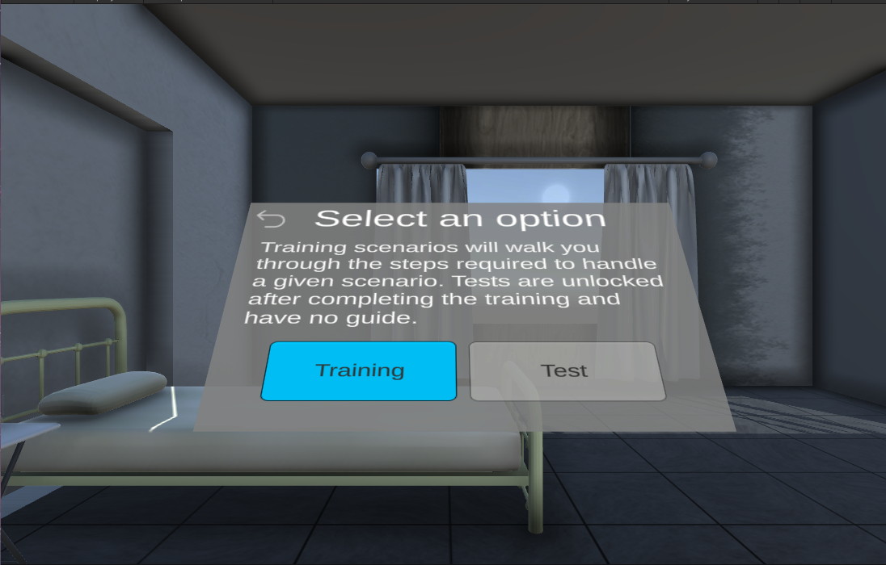

Figure 10 Bandage Scene – Mode Selection

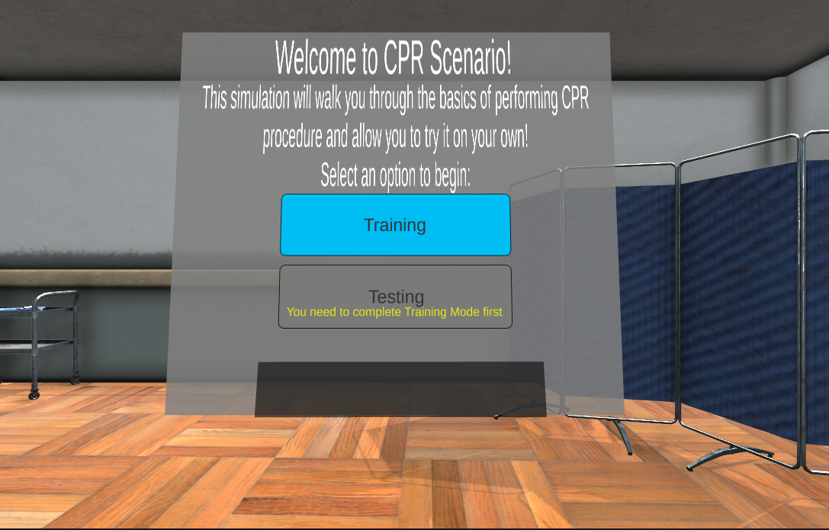

Figure 11 CPR Scene – Mode Selection

After selecting sub scenario and/or mode, corresponding scenario will start.

## Training Mode

If user selects Training mode, objectives will appear on the upper left side of the interface. Prompts will also appear near the objects to interact with at the current step. User’s actions are also accompanied with auditory and visual feedback (gestures) from non-playable character (NPC) doctor. Guidance is only provided in Training Mode since Testing mode is designed to test user’s knowledge.

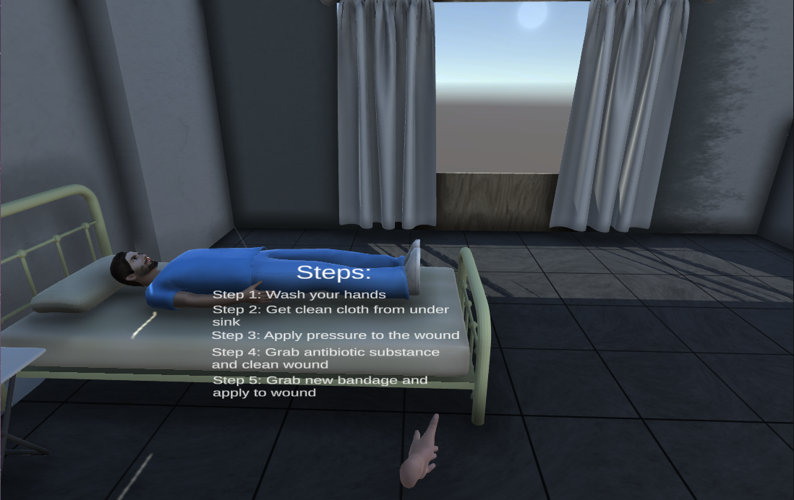

Figure Bandage Scene – Training – Small Cuts

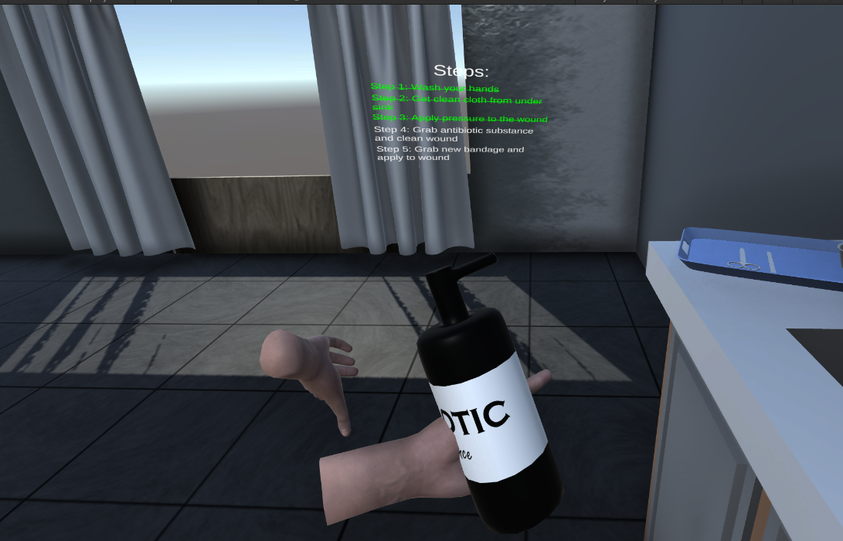

Figure Bandage Scene - Training - Antibiotic Interaction

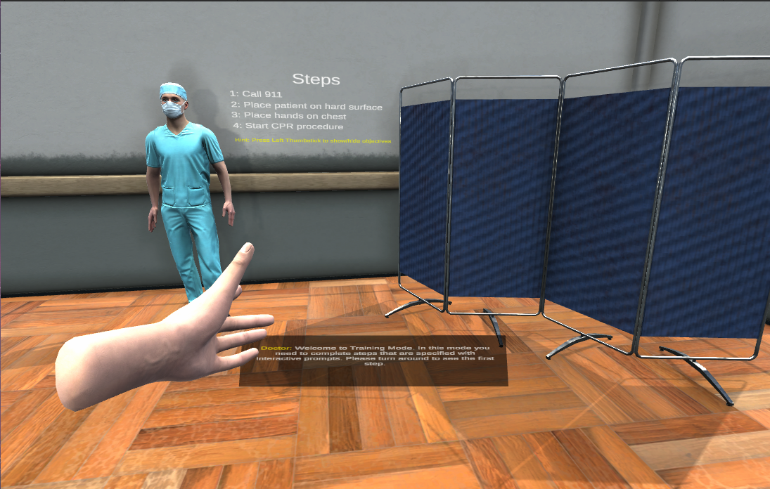

Figure CPR Scene – Training

Certain interactions will make additional UI elements appear, as can be seen on screenshot below. In the current example, user needs to complete CPR procedure and is given simulated progress and pressure bars. Progress bar will not register any progress if user does not apply enough simulated pressure (in this case, rapid vertical movement of both controllers above patient’s chest).

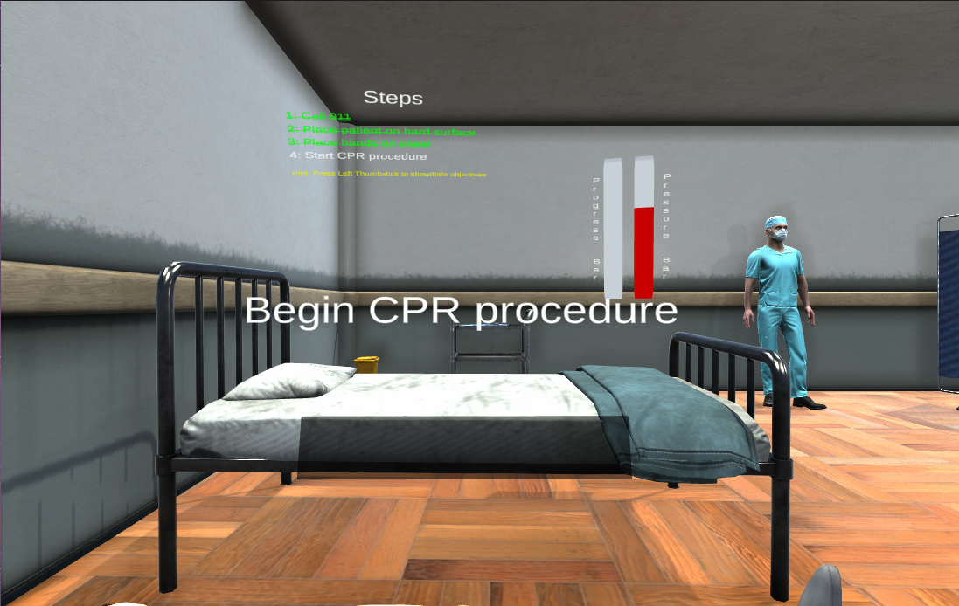

Figure 15 CPR - Training Mode – Additional UI Elements

After completing training mode, UI will appear with congratulatory message and notification that testing mode is now unlocked.

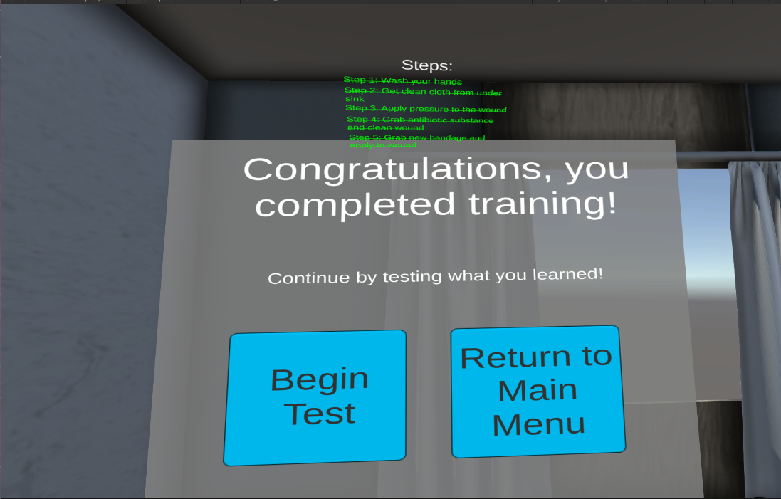

Figure Bandage Scene - Small Cuts Training Completed

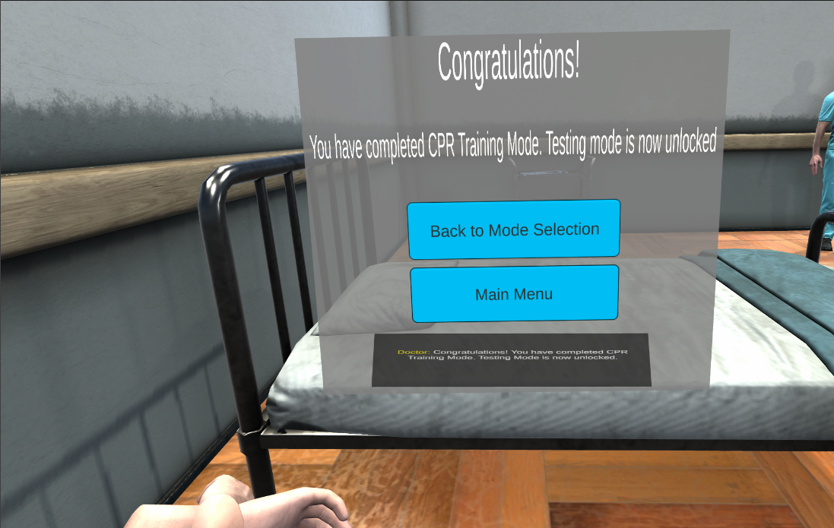

Figure CPR Scene - Training Completed

## Testing Mode

In testing mode, the user needs to complete the same actions they were walked through in training mode. There is no visual and audio feedback or guidance besides initial audio explaining that.

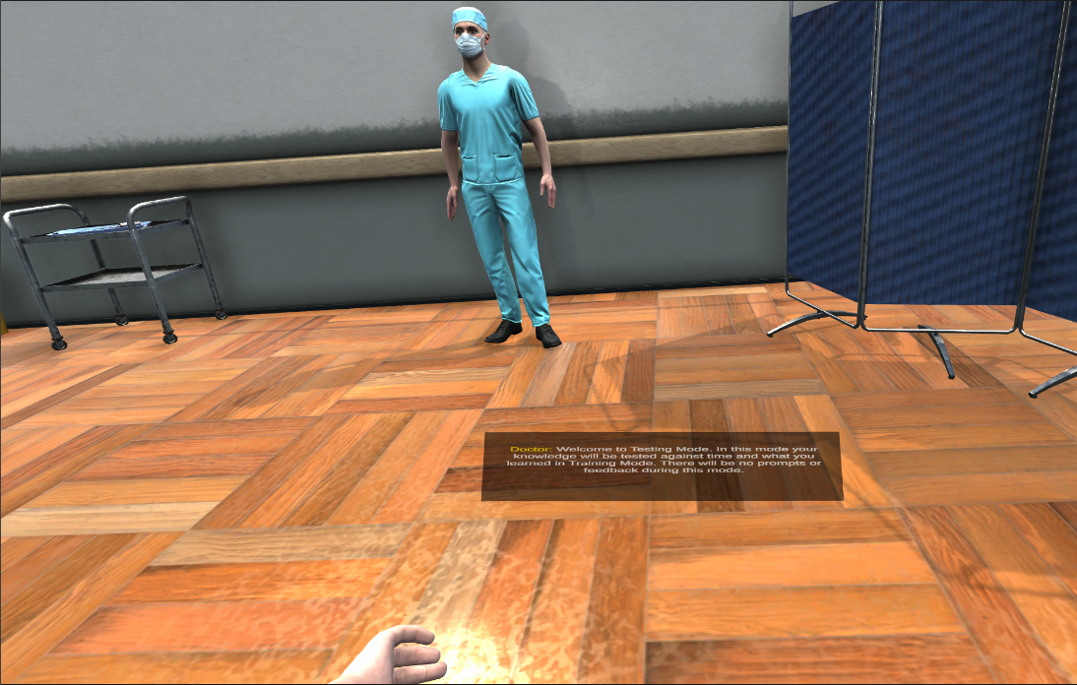

Figure CPR Scene - Beginning of Testing

Once audio is finished playing, timer will appear on the upper right side of interface.

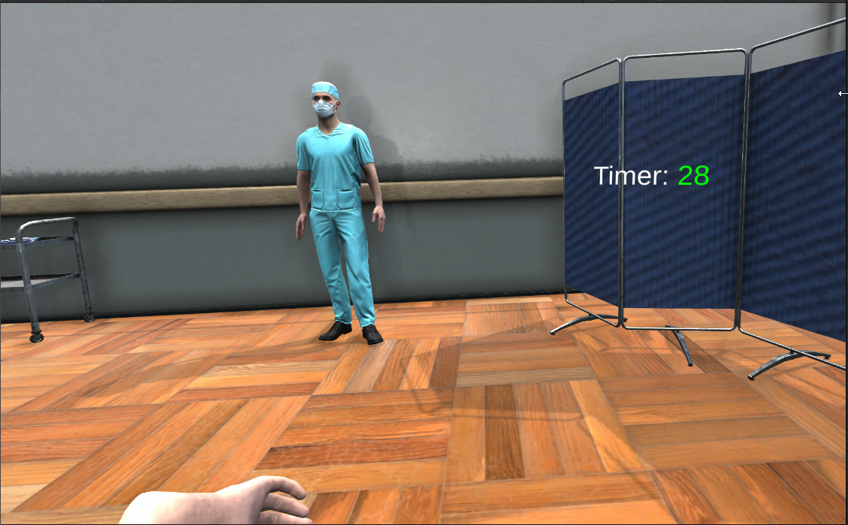

Figure Cpr Scene – Testing Timer

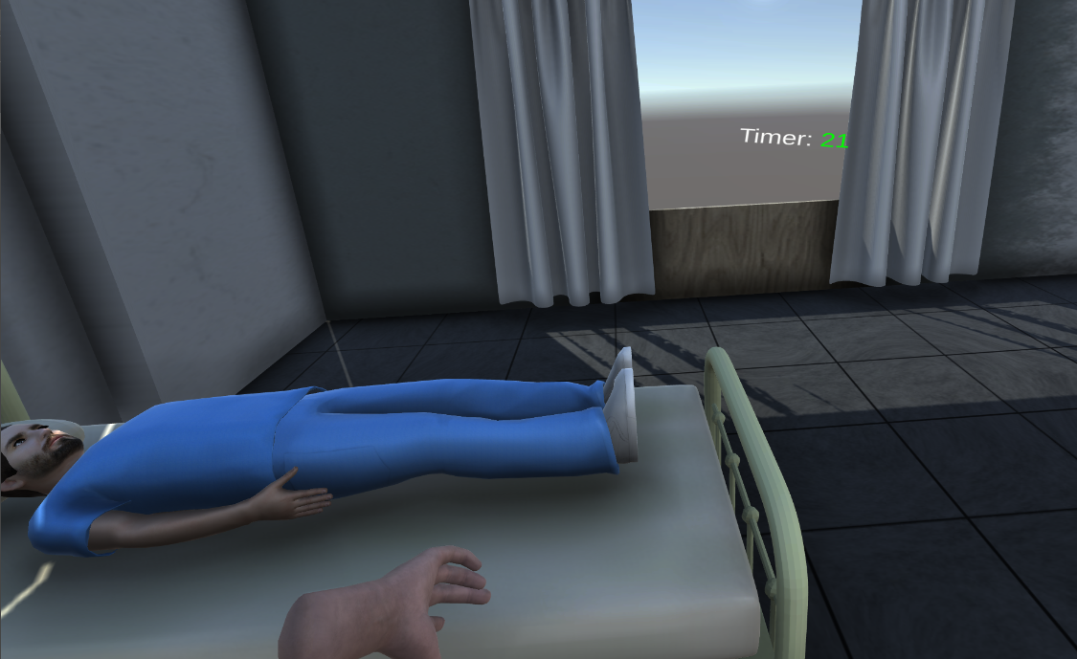

Figure Bandage Scene - Testing Timer

Depending on the result of testing mode, user will receive corresponding message.

* If user completed mode without any mistakes, UI with congratulatory message will appear

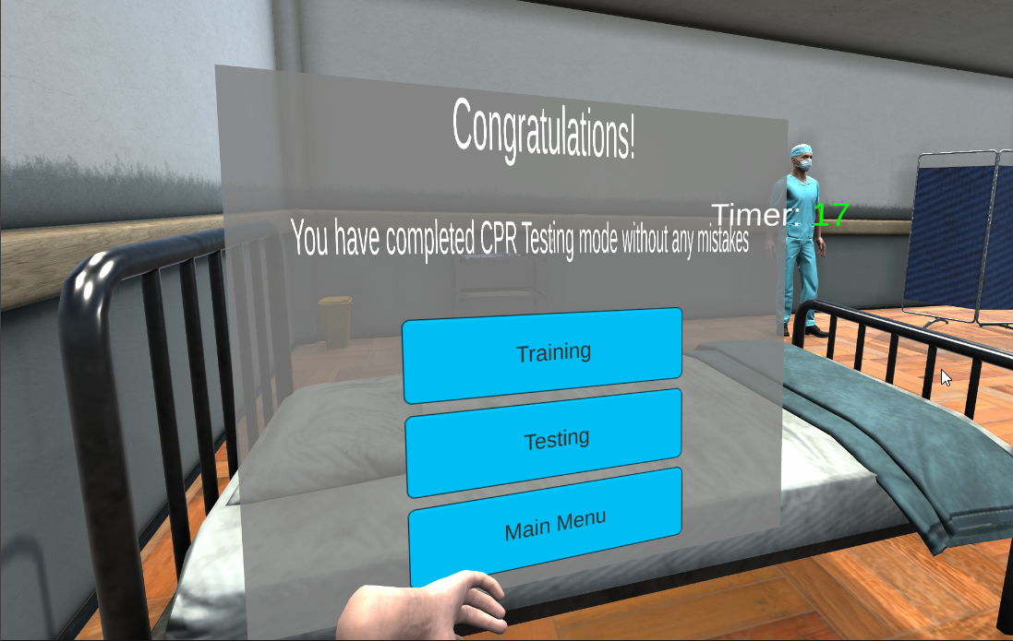

* If user made mistakes during testing mode, UI with message indicating number of errors will appear

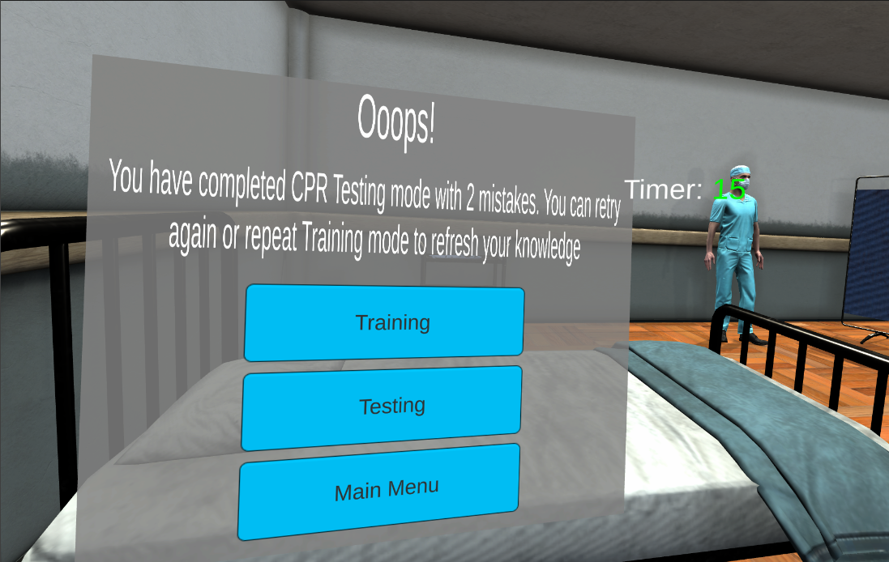

Figure CPR - Failed Testing

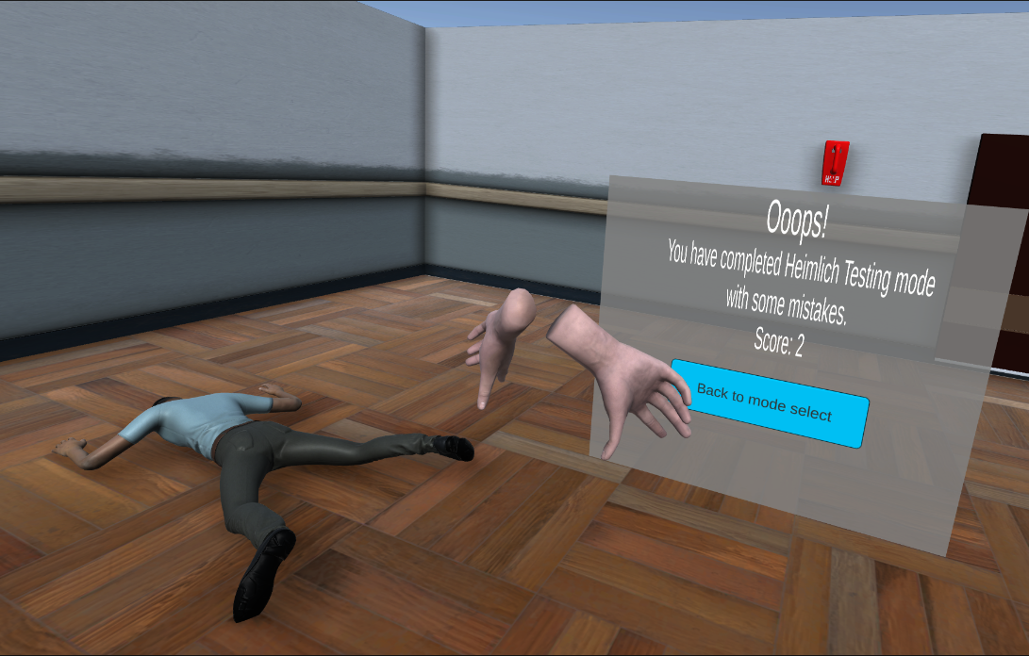

Figure Heimlich Maneuver - Failed Testing

* If the timer reached 0, the testing scenario will end notifying user that attempt is failed.

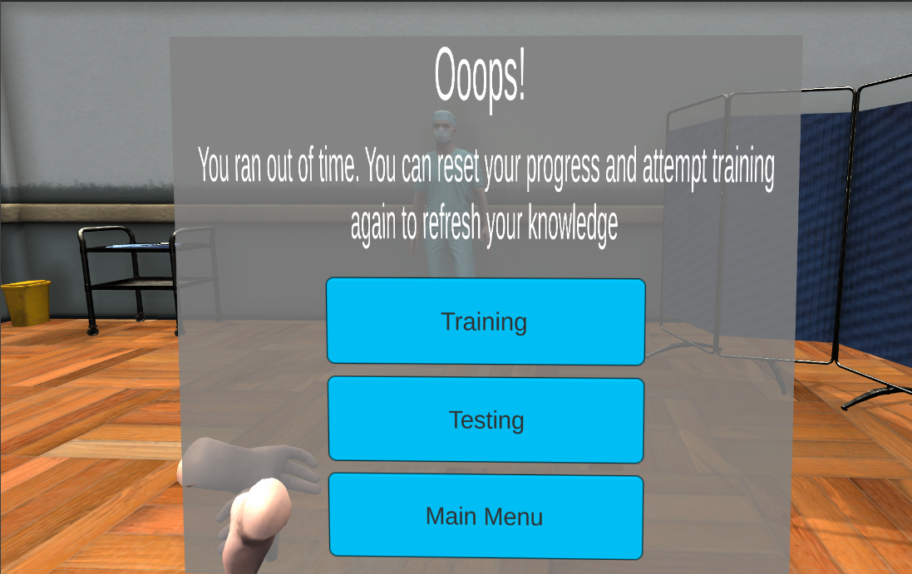

Figure CPR - Failed Testing

## Testing Scores

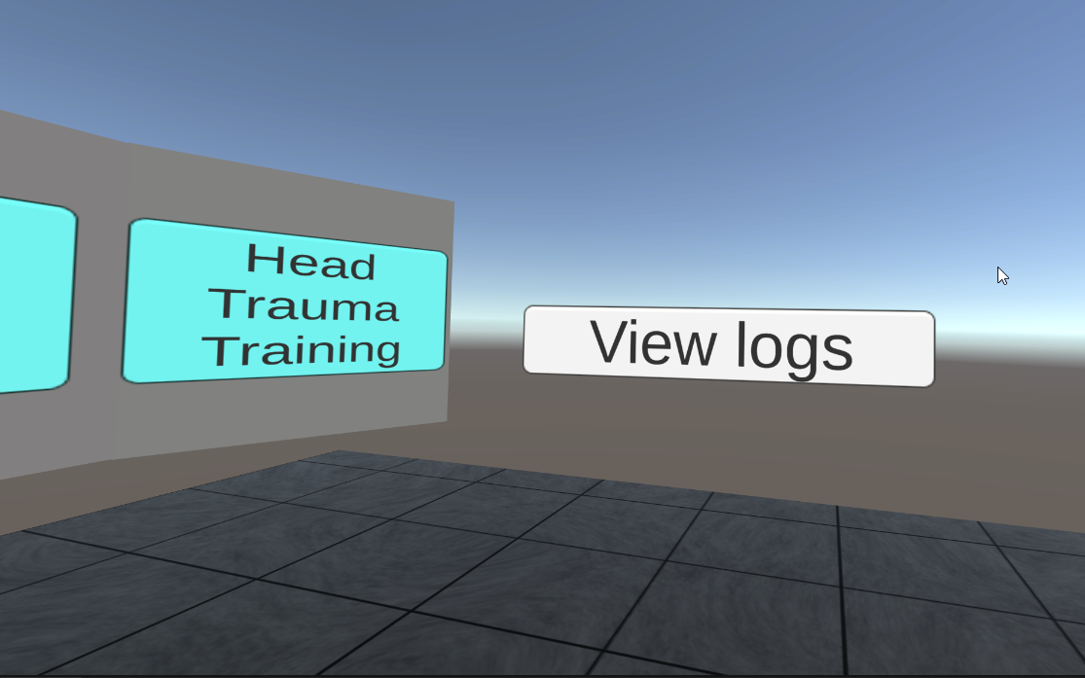

Figure Main Menu - Score Log

Users have the ability to check their testing mode scores in main menu. They can scroll through their results.

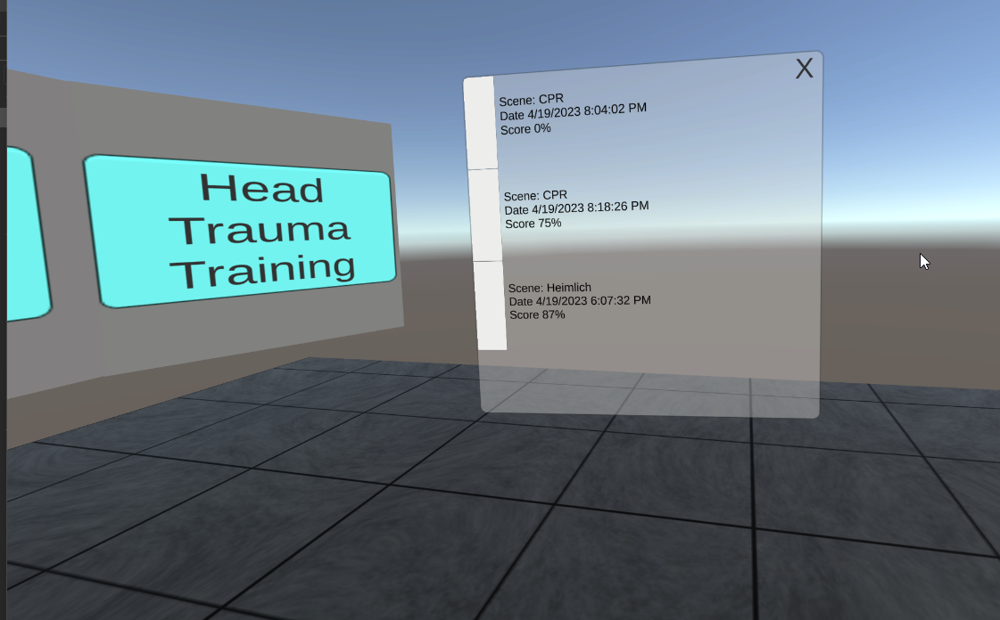

Figure All scores

By clicking on individual records, they can see details about scenario steps and what they did incorrectly.

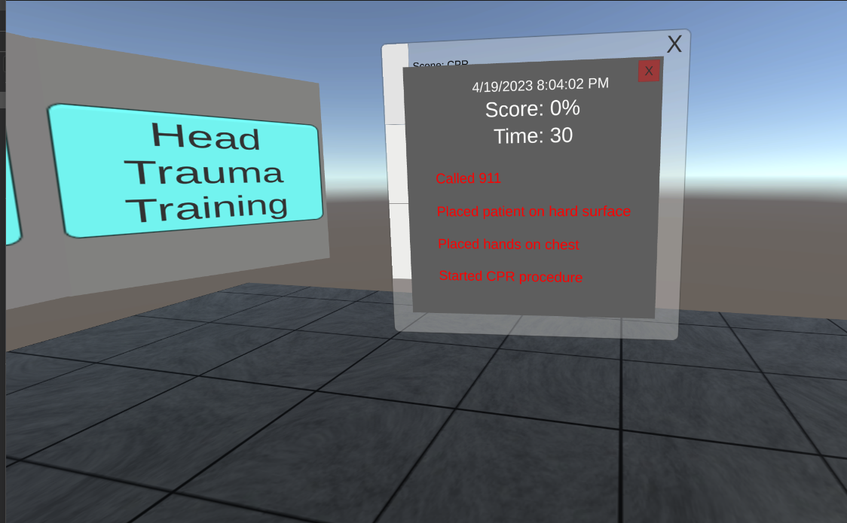

Figure Score for CPR Testing

Figure Score for Heimlich Maneuver Testing

## Additional Notes

In both testing and training mode, the user can return to the main menu by interacting with the door handle.

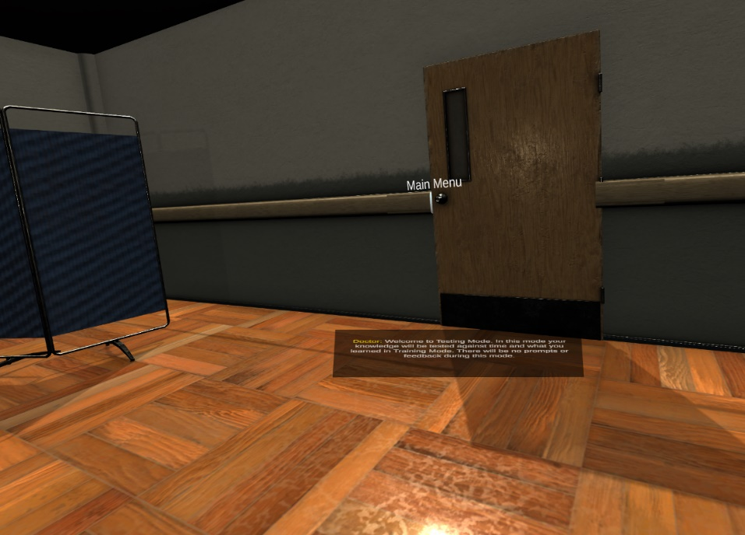

Figure 28 Return to Main Menu

Application can be exited the same way as other applications by using Menu button (refer to controllers diagram 3) on right controller.